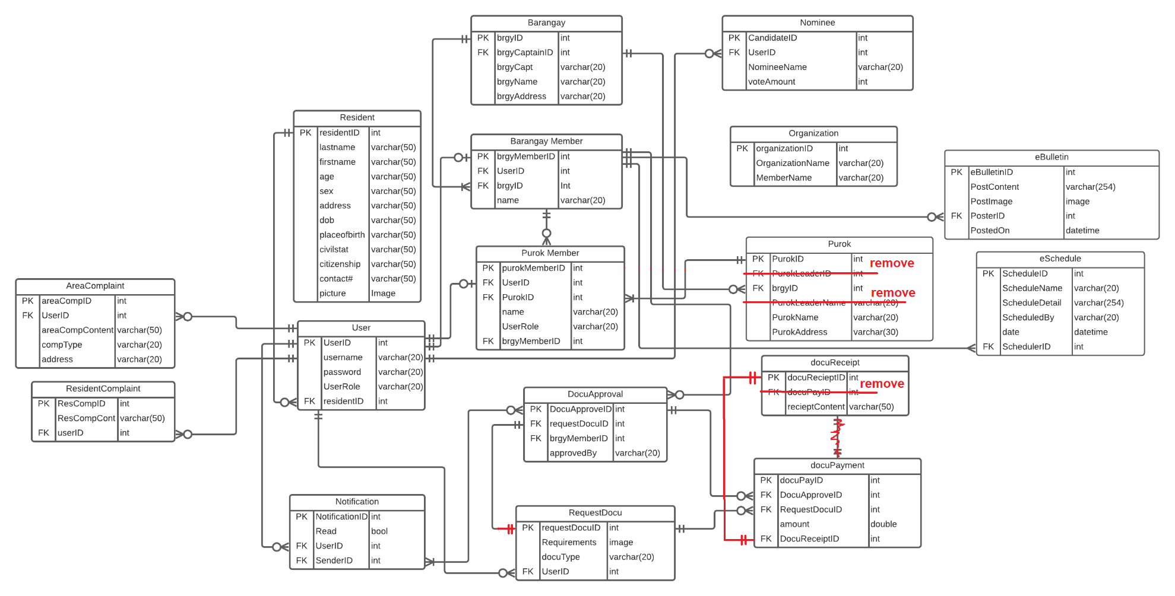**Entity Relationship Diagram**

**Data Dictionary**

A data dictionary is a collection of the names, definitions, and attributes for data elements and models. The data in a data dictionary is the metadata about the database. These elements are then used as part of a database, research project, or information system.

|  |  |  |  |  |  |  |  |  |
| --- | --- | --- | --- | --- | --- | --- | --- | --- |
| Table Name | Attribute Name | Contents | Type | Format | Range | Req  uired | PK OR FK | FK REFERENCED TABLE |
| Resident | ResidentID  Lastname  Firstname  Age  Sex  Address  Date of Birth  Place of Birth  Civil Status  Citizenship  Contact#  Picture | Resident ID  Resident’s Lastname  Resident’s Firstname  Resident’s Age  Resident’s Sex  Resident’s Age  Resident’s DOB  Resident’s Place of Birth  Resident’s Civil Status  Resident’s Citizenship  Resident’s Contact#  Resident’s 2x2 Pic | INT  VARCHAR(50)  VARCHAR(50)  VARCHAR(50)  VARCHAR(50)  VARCHAR(50)  VARCHAR(50)  VARCHAR(50)  VARCHAR(50)  VARCHAR(50)  VARCHAR(50)  IMAGE | 999999  Xxxx xxxxx  Xxxx xxxxx  Xxxx xxxxx  Xxxx xxxxx  Xxxx xxxxx  Xxxx xxxxx  Xxxx xxxxx  Xxxx xxxxx  Xxxx xxxxx  Xxxx xxxxx | 000001-999999 | Y  Y  Y  Y  Y  Y  Y  Y  Y  Y  Y | PK |  |
| User | UserID  Username  Password  UserRole  residentID | User’s ID  Username for login  Password for login  Roles of the User  Resident ID linked | INT  VARCHAR(20)  VARCHAR(20)  VARCHAR(20)  INT | 999999  Xxxx xxxxx  Xxxx xxxxx  Xxxx xxxxx  999999 | 000001-999999  000001-999999 | Y  Y  Y  Y | PK  FK | Resident |
| Notification | NotificationID  Read  UserID  SenderID | Notification’s ID  Read status  User’s ID  Sender’s ID | INT  BOOL  INT  INT | 999999  X  999999  999999 | 000001-999999  000001-999999  000001-999999 | Y  Y  Y  Y | PK  FK  FK | User  DocuApproval |
| Barangay | BrgyID  BrgyCaptainID  BrgyCaptName  BrgyName  BrgyAddress | Barangay ID  Brgy captain’s brgymemberID  Barangay Captain’s Name  Barangay Name  Barangay Address | INT  INT  VARCHAR(20)  VARCHAR(20)  VARCHAR(20) | 999999  999999  Xxxx xxxxx  Xxxx xxxxx  Xxxx xxxxx | 000001-999999  000001-999999 | Y  Y  Y  Y  Y | Y | Barangay Member |
| Barangay Member | BrgyMemberID  UserID  BrgyID  Name | Barangay member’s ID  User’s ID  Barangay ID  Barangay Member’s name | INT  INT  INT  VARCHAR(20) | 999999  999999  999999  Xxxx xxxxx | 000001-999999  000001-999999  000001-999999 | Y  Y  Y  Y | PK  FK  FK | User  Barangay |

|  |  |  |  |  |  |  |  |  |  |  |  |
| --- | --- | --- | --- | --- | --- | --- | --- | --- | --- | --- | --- |
| Purok | PurokID  BrgyID  PurokName  PurokAddress | Purok ID  Barangay’s ID  Purok’s Name  Purok’s Address | INT  INT  VARCHAR(20)  VARCHAR(20) | 999999  999999  Xxxx xxxxx  Xxxx xxxxx | 000001-999999  000001-999999 | Y  Y  Y  Y | | PK  FK | Barangay | | |
| Purok Member | purokMemberID  UserID  PurokID  Name  UserRole | Purok Member’s ID  User ID  Purok’s ID  Purok Member’s Name  Purok Member’s Role | INT  INT  INT  VARCHAR(20)  VARCHAR(20) | 999999  999999  999999  Xxxx xxxxx  Xxxx xxxxx | 000001-999999  000001-999999  000001-999999 | Y  Y  Y | | PK  FK  FK | User  Purok Member | | |
| Nominee | NomineeID  UserID  VoteAmount | Nominee’s ID  User’s ID  Amount of votes they got | INT  INT  INT | 999999  999999  999999 | 000001-999999  000001-999999  000001-999999 | Y  Y  Y | | PK  FK | User | | |
| Organization | OrganizationID  OrganizationName  MemberName | Organization’s ID  Organization’s Name  Member’s Name | INT  VARCHAR(20)  VARCHAR(20) | 999999  Xxxx xxxxx  Xxxx xxxxx | 000001-999999 | Y  Y  Y | | PK |  | | |
| Notification | NotificationID  Read  UserID  SenderID | Notification’s ID  Check user read status  User’s ID  Sender’s ID | INT  BOOL  INT  INT | 999999  X  999999  999999 | 000001-999999  0-1  000001-999999  000001-999999 | Y  Y  Y | | PK  FK  FK | User  DocuApproval | | |
| DocuApproval | DocuApprovalID  RequestDocuID  BrgyMemberID  ApprovedBy | Approved document’s ID  Requested document’s ID  Barangay Member’s ID  Approved by name of brgy member | INT  INT  INT  VARCHAR(20) | 999999  999999  999999  Xxxx xxxxx | 000001-999999  000001-999999  000001-999999 | Y  Y  Y  Y | | PK  FK  FK | RequestDocu  Purok Member | | |
| RequestDocu | RequestDocuID  Requirements  DocuType  UserID | Requested Document’s ID  Requirements needed  Document type  User’s ID | INT  IMAGE  VARCHAR(20)  INT | 999999  Xxxx xxxxx  999999 | 000001-999999  000001-999999 | Y  Y  Y | | PK  FK | User | | |
| DocuPayment | DocuPayID  DocuApproveID  RequestDocuID  Amount  DocuReceiptID | Docupay’s ID  Approved document’s ID  Requested Document’s ID  Amount to be paid  Receipt for transaction | INT  INT  INT  NUMBER(9,2)  INT | 999999  999999  999999  999999999.99  999999 | 000001-999999  000001-999999  000001-999999  000000001.00-999999999.99  000001-999999 | Y  Y  Y  Y  Y | | PK  FK  FK  FK | DocuApproval  RequestDocu  DocuReceipt | | |
| DocuReceipt | DocuReceiptID  ReceiptContent | DocuReceipt’s ID  Receipt’s Content | INT  VARCHAR(20) | 999999  Xxxx xxxxx | 000001-999999 | Y | | PK |  | | |
| eBulletin | eBulletinID  PostContent  PostImage  PosterID  PostedOn | eBulletin’s ID  Content of the Post  Image of the Post  brgyMemberID of the poster  Date posted on | INT  VARCHAR(254)  IMAGE  INT  DATETIME | 999999  Xxxxx xxxxx  999999  MMMM/dd/YY HH:MM | 000001-999999  000001-999999 | | Y  Y  Y  Y | PK  FK | | Barangay Member |
| eSchedule | ScheduleID  ScheduleName  ScheduleDetail  ScheduledBy  Date  SchedulerID | Schedule’s ID  Name of the event  Details of the event  Name of the scheduler  Date of the event  Barangay Member’s ID | INT  VARCHAR(20)  VARCHAR(254)  VARCHAR(20)  DATETIME  INT | 999999  Xxxxx xxxxx  Xxxxx xxxxx  Xxxxx xxxxx  MMMM/dd/YY HH:MM  999999 | 000001-999999  000001-999999 | | Y  Y  Y  Y  Y  Y | PK  FK | | Barangay Member |